**BLUEGRASS HEALTHCARE COALITION**

**HAZARD VULNERABILTY ASSESSMENT**

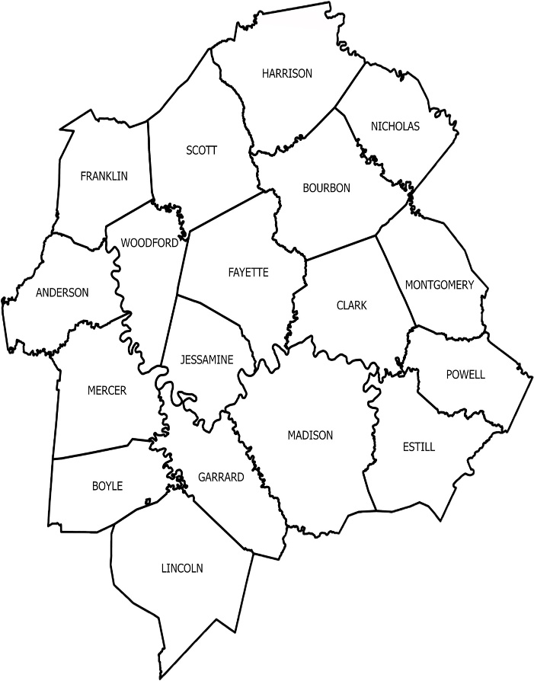

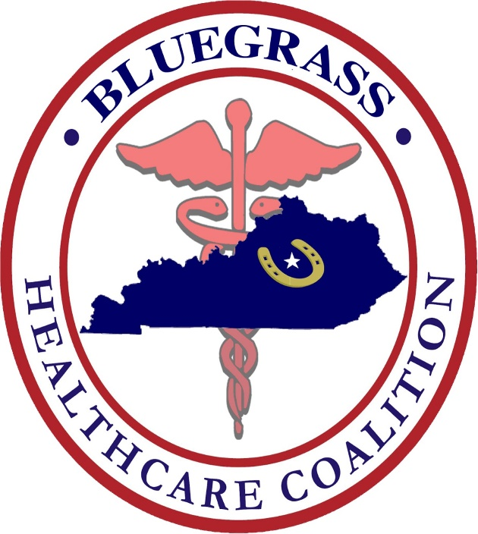

**FY 2024/2025**

The Bluegrass Healthcare Coalition (BGHCC) conducted an annual review of the region’s Hazard Vulnerability Assessment (HVA) completed on **November 29th, 2024**. A ReadyOp Survey link was sent to Healthcare Coalition members to report their top 5 hazards for 2024. The results were compiled and reviewed during the Coalition meeting on **Dec. 19th ,2024**.

BGHCC Executive Committee recently decided to shorten the length for Coalition members to provide HVA feedback from 5 years to 3 years. Posted below are HVA collective results from 35 agencies represented in the Bluegrass Healthcare Coalition region.

Regional Hazard Vulnerability (Hazard-Type Rankings). Number in parenthesis reflects overall cumulative ranking.

**Naturally Occurring Event:**

1. Severe Thunderstorm (1)
2. Tornado (2)
3. Epidemic / Pandemic (5)
4. Ice Storm (7)
5. Snow Fall (10)

**Technological Events:**

1. Electrical Failure (4)
2. Information Systems Failure (6)
3. Communications Failure (8)
4. Hazmat Exposure, Internal (9)
5. Supply Shortage (11)

**Human Related Events**

1. Mass Casualty Incident (trauma) (3)
2. Mass Casualty Incident (medical / infectious) (14)
3. Civil Disturbance (19)
4. Workplace Violence (22)
5. Bomb Threat (25)

Attached is the completed HVA worksheet. This information will be used in work plan development, budget planning and exercise development for the improvement of preparedness and response in the Bluegrass HCC region.

Readiness and Response Coordinators:

|  |  |
| --- | --- |
| Dave Carney  DavidN.Carney@ky.gov | JT Moore  Jordan.Moore@ky.gov |

HVA point summation

**This information will be reassessed annually per Coalition bylaws.



*** The BGHCC Regional HVA is reviewed annually by the Executive Committee to ensure all hazards are current and to recommend adjustments as necessary. The next collective BGHCC member HVA will be conducted in **FY 27/28.**