BLUEGRASS HEALTHCARE COALITION
HAZARD VULNERABILTY ASSESSMENT
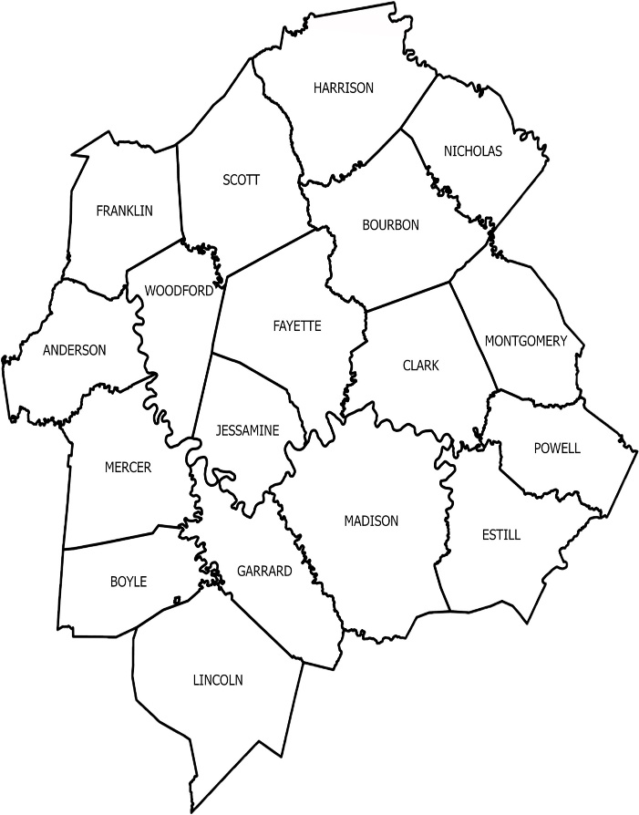
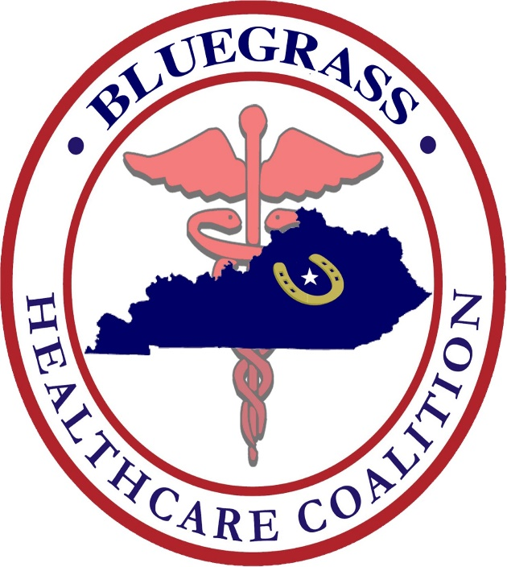

FY 2025/2026

The Bluegrass Healthcare Coalition (BGHCC) conducted an annual review of the region’s Hazard Vulnerability Assessment (HVA) completed on August 21st, 2025.

BGHCC Executive Committee recently decided to shorten the length for Coalition members to provide HVA feedback from 5 years to 3 years. Posted below are HVA collective results from 35 agencies represented in the Bluegrass Healthcare Coalition region.

Regional Hazard Vulnerability (Hazard-Type Rankings). Number in parenthesis reflects overall cumulative ranking.
Naturally Occurring Event:
- Severe Thunderstorm (1)
- Tornado (2)
- Epidemic / Pandemic (5)
- Ice Storm (7)
- Snow Fall (10)

Technological Events:
- Electrical Failure (4)
- Information Systems Failure (6)
- Communications Failure (8)
- Hazmat Exposure, Internal (9)
- Supply Shortage (11)

Human Related Events
- Mass Casualty Incident (trauma) (3)
- Mass Casualty Incident (medical / infectious) (14)
- Civil Disturbance (19)
- Workplace Violence (22)
- Bomb Threat (25)

Attached is the completed HVA worksheet. This information will be used in work plan development, budget planning and exercise development for the improvement of preparedness and response in the Bluegrass HCC region.

Readiness and Response Coordinators:
Dave Carney  DavidN.Carney@ky.gov | JT Moore  Jordan.Moore@ky.gov

HVA point summation

**This information will be reassessed annually per Coalition bylaws.

*** The BGHCC Regional HVA is reviewed annually by the Executive Committee to ensure all hazards are current and to recommend adjustments as necessary. The next collective BGHCC member HVA will be conducted in FY 27/28.

